**AngularJS**

**Name :** Murali S

**RollNo :** CB.EN.U4CSE19635

**Date :** 27.10.22

**Idea:**

Created a feedback form for user to enter comment

User shows the value entered in the textbox and master shows tha value which have been saved

While reset restore the value to same as master box

**Pics:**

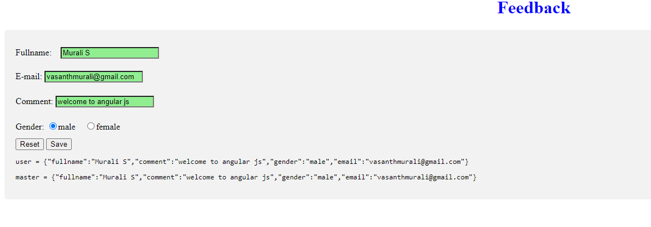

Css has been used to check value has been entered or not, and to verify the value is correct or not

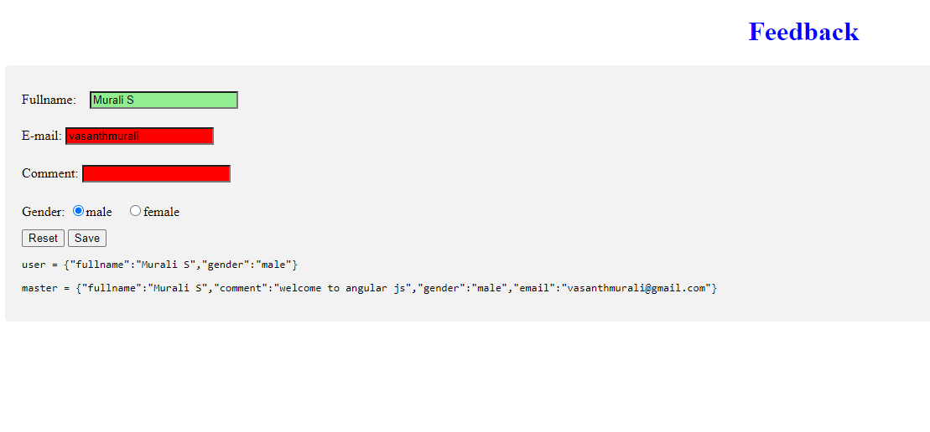

User show the value in the textbox entered

After pressing reset it will restore to same as master

